|  |  |  |  |  |  |
| --- | --- | --- | --- | --- | --- |
| Date | 19-Sep-22 | | | Tester Name | Shahabuddin Syed |
| Environment | Penfax - Test | | | Login used |  |
| Operating System | Select OS | Version: | Update: | | |
| Software Used | Select Software | Version: | Update: | | |
| Select Software | Version: | Update: | | |
| Release version | 22.4.1 | | | | |
| Title | E21.01 | | | | |
| Test Type | Regression | | | | |
| Test Scenario | Case Management – Create a Retirement Payment Case & complete it | | | | |
|  |  | | | | |
| Expected Results |  | | | | |
| Pass/Fail | Pass | | | JIRA# | N/A |

Describe your steps with screenshots:

Search for an active member in the PEPP Plan

In Penfax do a member search

Click on their stakeholder ID Number

Select Stakeholder ID

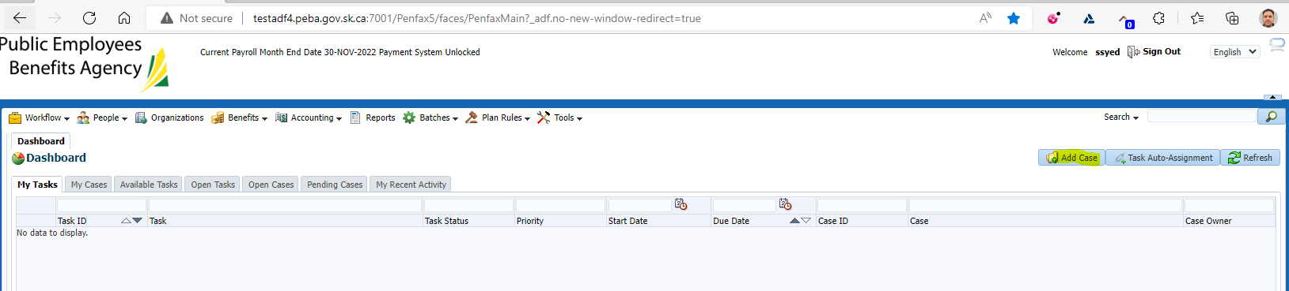

Click on Stakeholder ID - 314116

New window opens up with Member Profile

Under Case Type select Retirement Payment Case  
Click Save

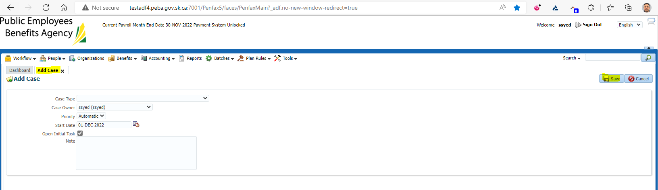

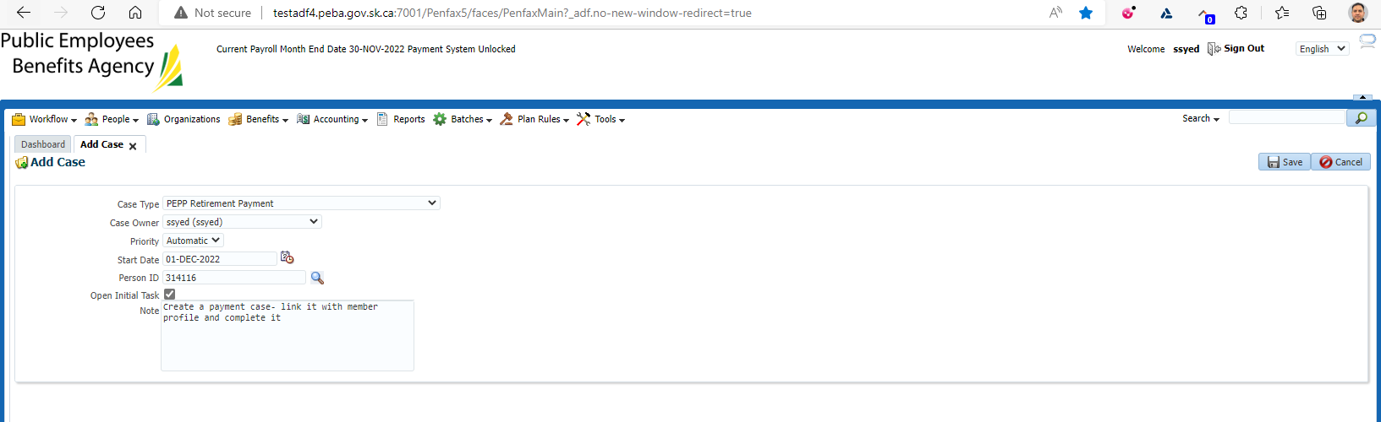

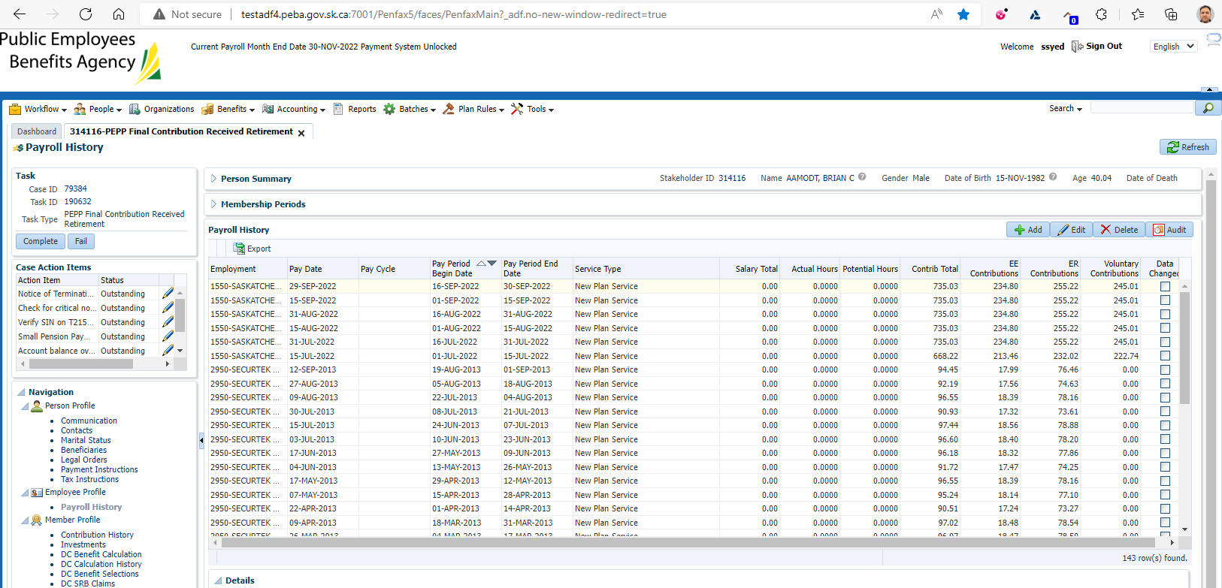

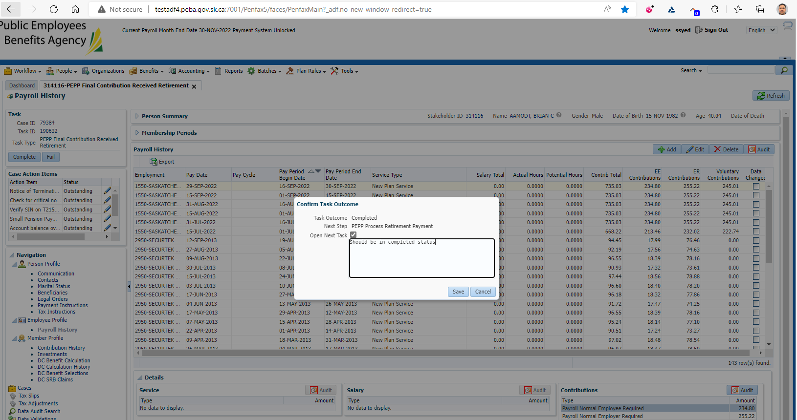

Complete all the tasks for the status showing as outstanding

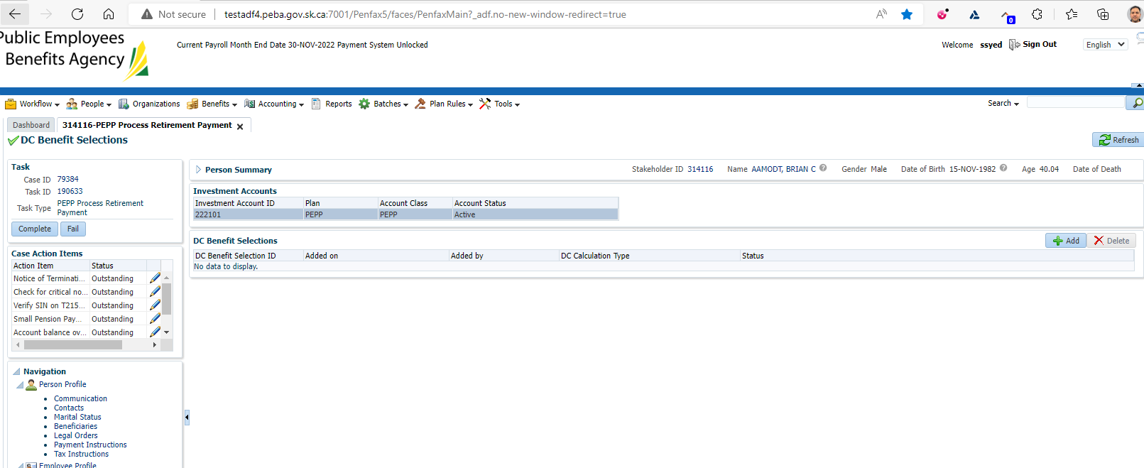

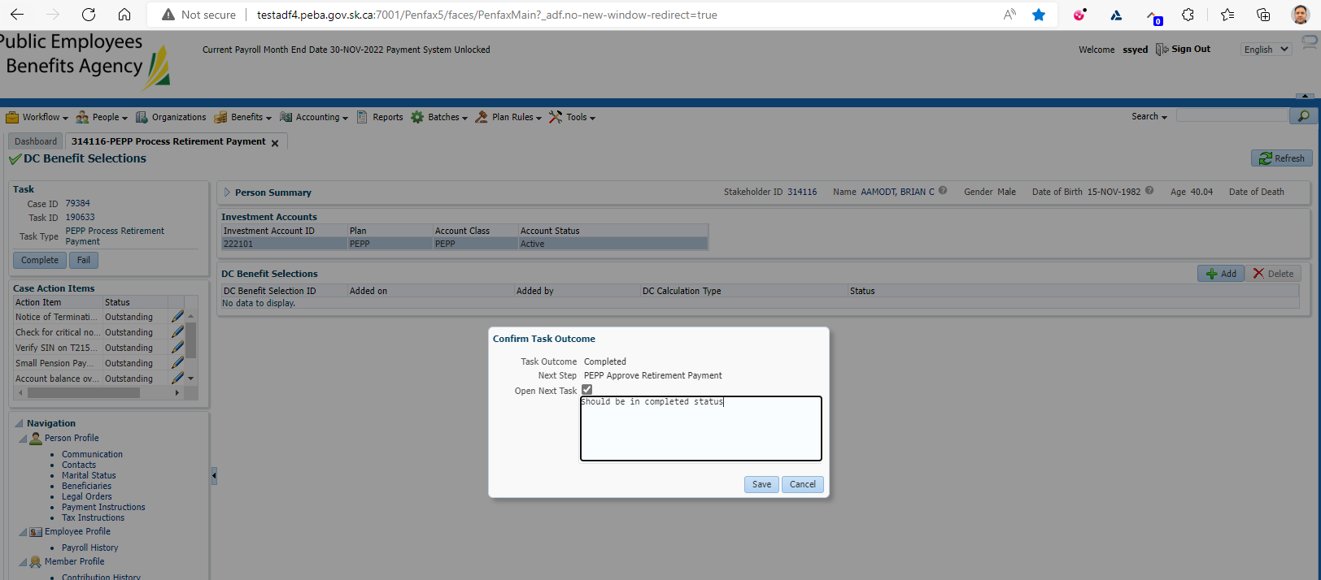

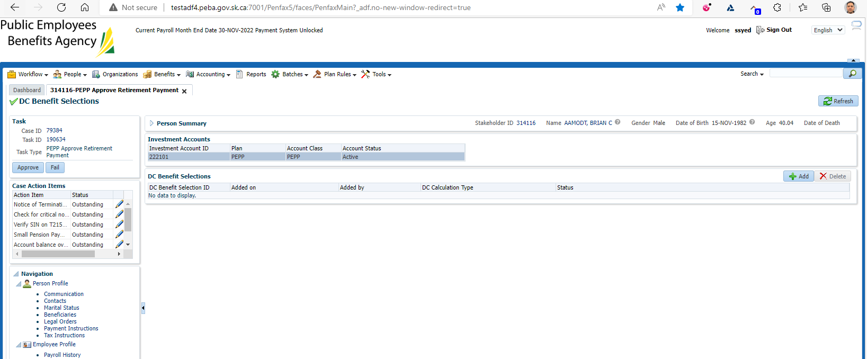

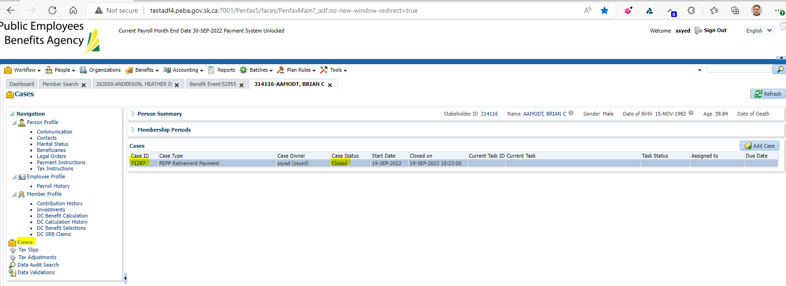

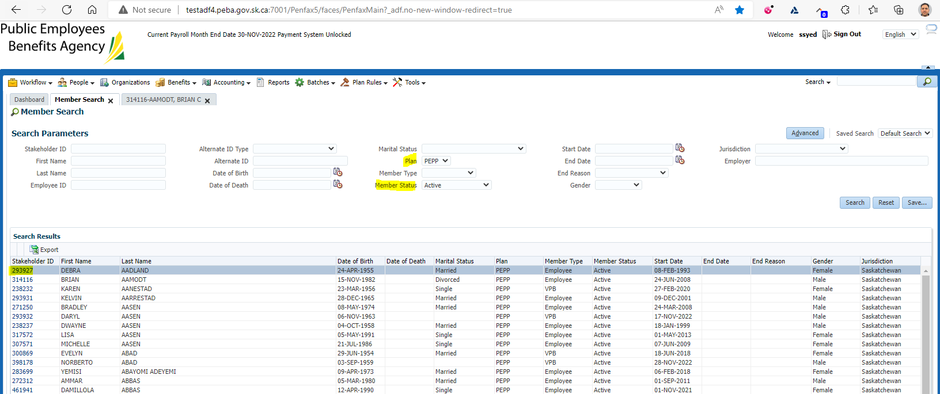

Under Navigation click on Cases  
Click Add Case

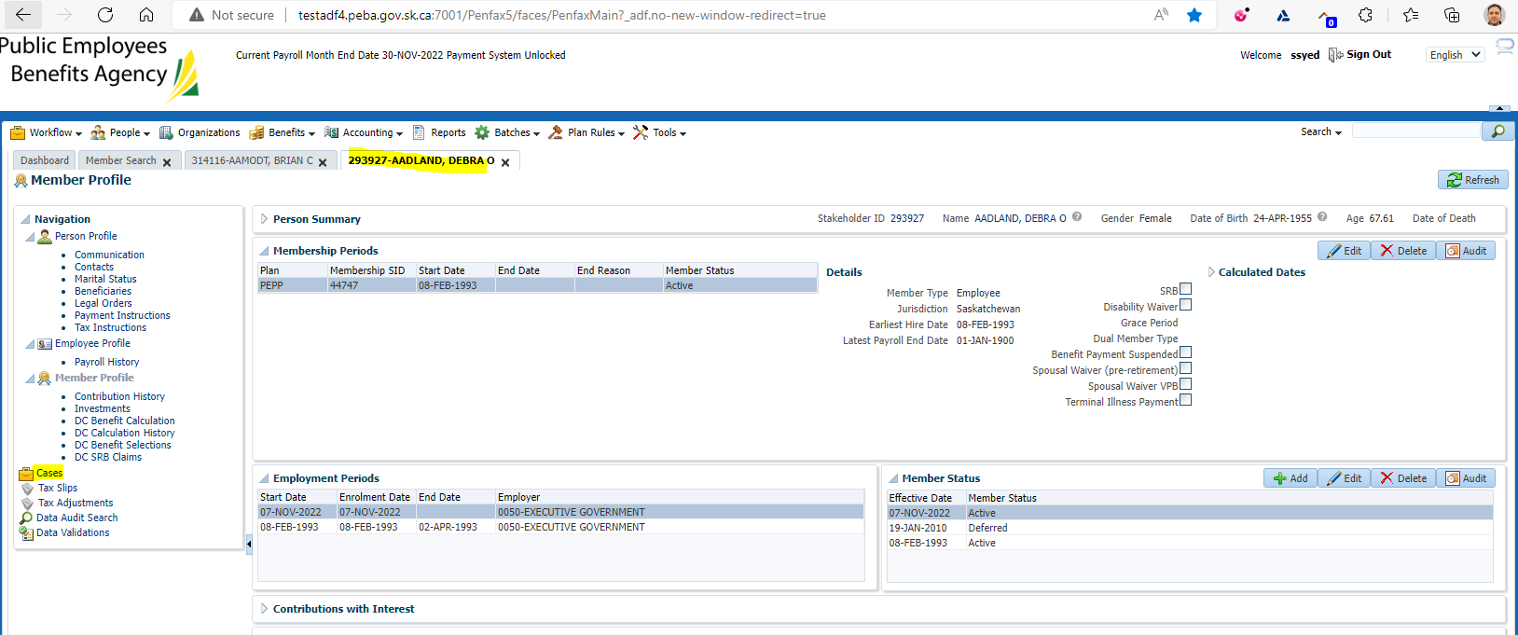

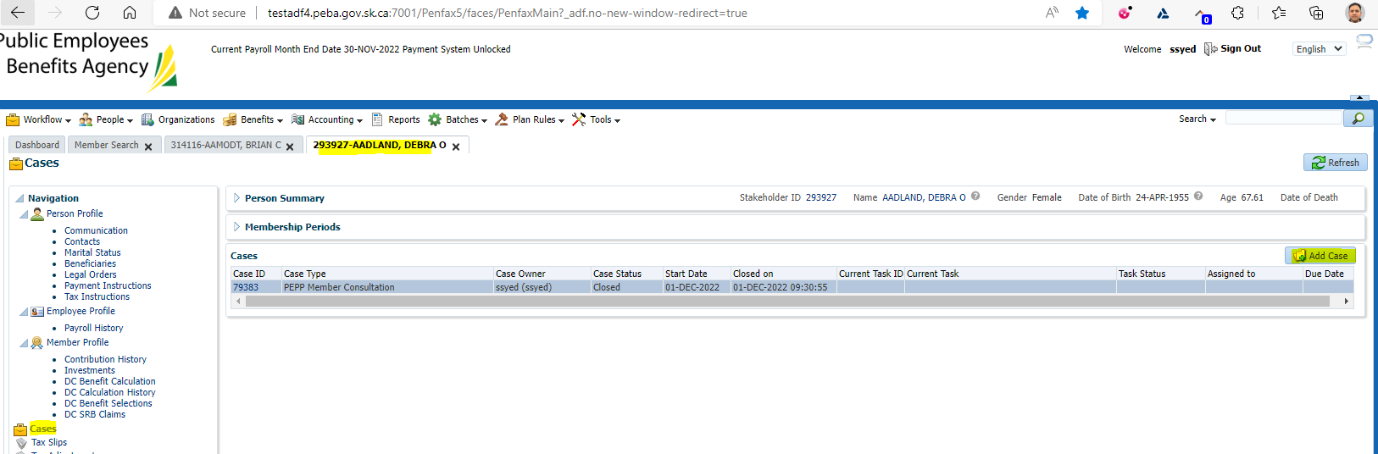

Click on Complete

Complete all necessary steps

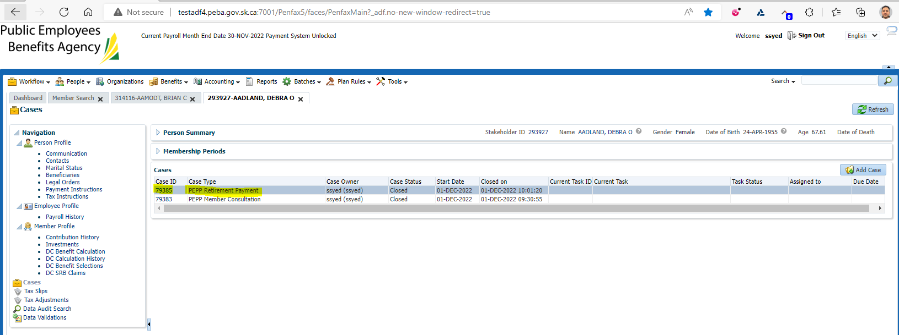

Under Workflow go to Case Search   
Search for the Case you just completed

